Priteesh Jhamna

Abstract

The aim of this report is to find the location with the highest rating for sushi places.

Finding which borough has the highest rating for sushi places

Contents

INTRODUCTION/PROBLEM STATEMENT 2

DATA 2

METHODOLOGY 2

RESULTS 3

DISCUSSION 4

CONCLUSION 4

# INTRODUCTION/PROBLEM STATEMENT

#### In the recent years, the Japanese dish sushi has become more and more popular and many sushi shops have opened in New York city and its borough. With so over 100 of shops to choose from, it has become a problem for people to find the best one to pick to satisfy their sushi cravings. Since it is not possible to pick a restaurant for someone because everyone has a different taste, it is better to find out which borough have the best ratings for sushi places. In this manner, people can decide which sushi place suits them the most knowing that all the sushi places around them are of high ratings. This project is aimed to help sushi lovers to find in which borough the highest ratings sushi places are located.

# DATA

#### In order to be able to reach a conclusion, data analysis of existing shops in New York city has to be performed. Two sets of essential data are to be looked at. Firstly, the location,i.e the neighborhood of New York city and this data has been collected from the following url <https://cocl.us/new_york_dataset>. Secondly, I am using Foursquare API to find the sushi shops.

# METHODOLOGY

#### During this analysis process, data analysis and visualization such as bar charts will be made in order to find the borough with the sushi place with the best ratings by collecting data from Foursquare

The following is a sample of the data collected:

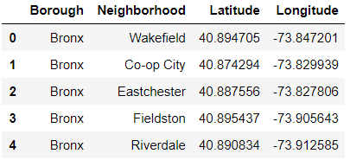

The next step was to find the longitude and latitude by using Geopy. I then proceeed to in the number of sushi places in the different boroughs and used a bar chart to facilitate the visualization of the data. The following is a screenshot of the barchart:

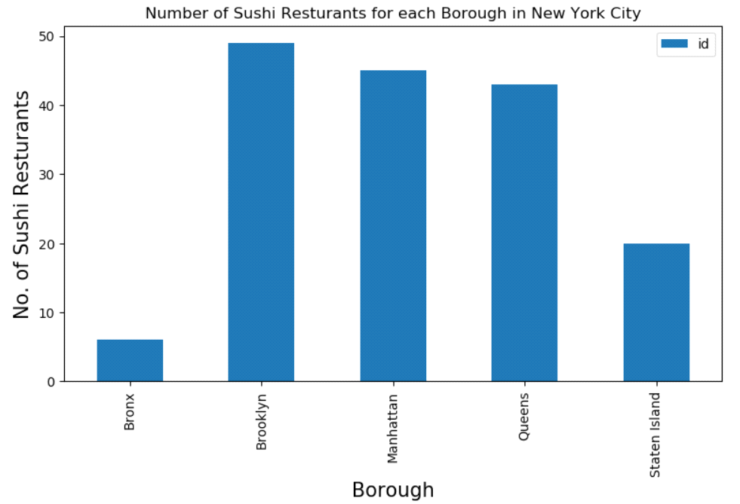

It is seen from the barchart that Brooklyn has the highest number of sushi places followed by Manhattan and Bronx had the lowest number of sushi restaurants.

# RESULTS

This section will provide my findings.

The following is a sample of the data in my findings:

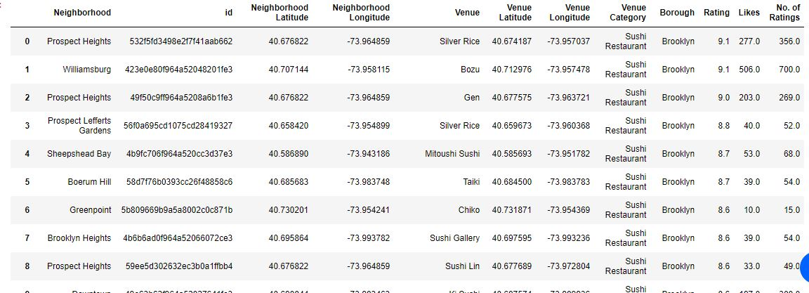

Considering a rating less than 8.0 to be bad, the next step was to drop all the locations with the bad rating and the following is a screenshot of the result:

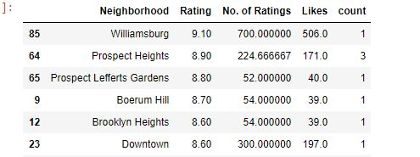

The next step was to group the data by borough to find out which borough had the highest ratings and the following table shows the result:

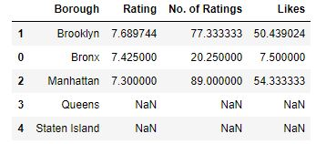

# DISCUSSION

From the above analysis it has been found that the top three boroughs which have the highest ratings and most likes are Brooklyn, Bronx and Manhattan. This information has made it possible for us to decide that Brooklyn has the highest rating for the best sushi location.

# CONCLUSION

In conclusion, this project has made it possible to identify which borough has the highest rating for the best sushi place and has made it easier for sushi lovers to find a location to pick a restaurant to eat from. From the analysis performed in this project, Brooklyn was found to be the borough with the highest rating of 7.69.